**Create Node-RED Service**

|  |  |
| --- | --- |
| Date | 08 November 2022 |
| Team ID | PNT2022TMID19760 |
| Project Name | SmartFarmer – IoT ENABLED SMART FARMING APPLICATION |

STEP 1:

Login your IBM cloud.

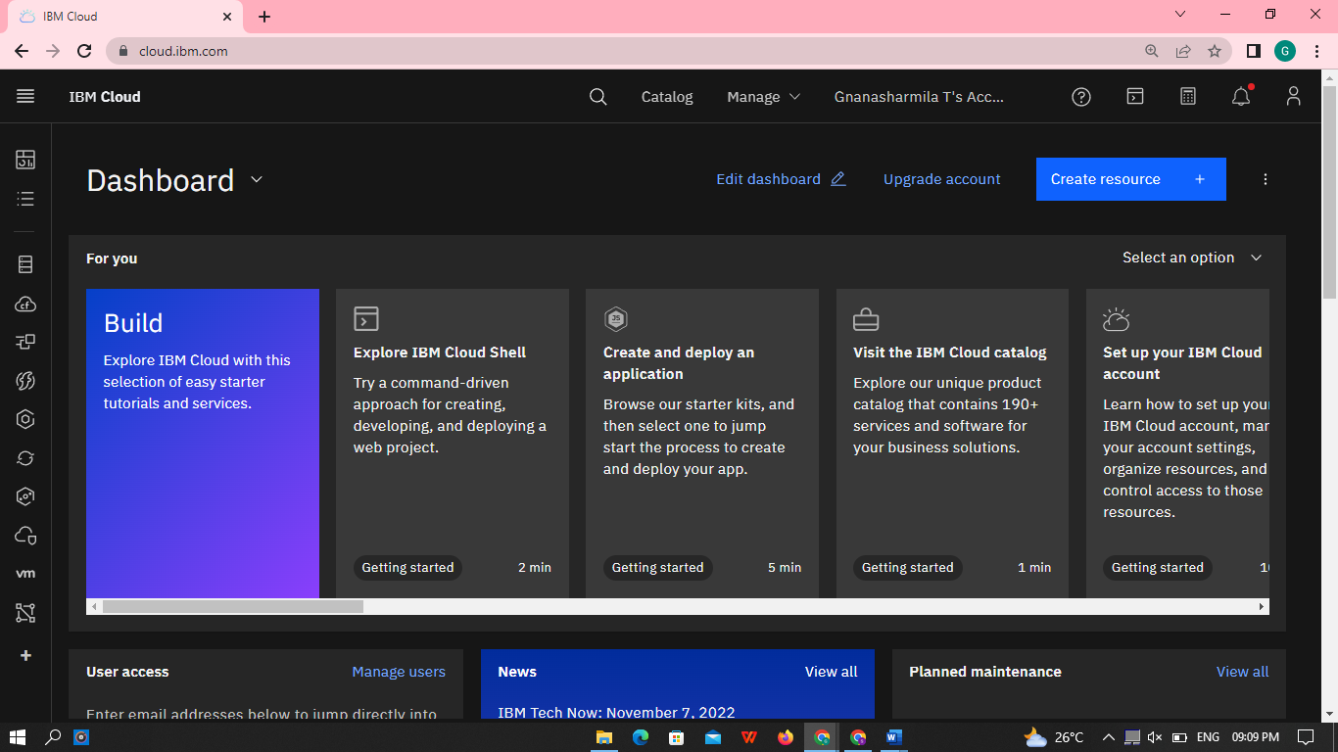

STEP 2:

Catalog where you find the services and Search Node Red app.

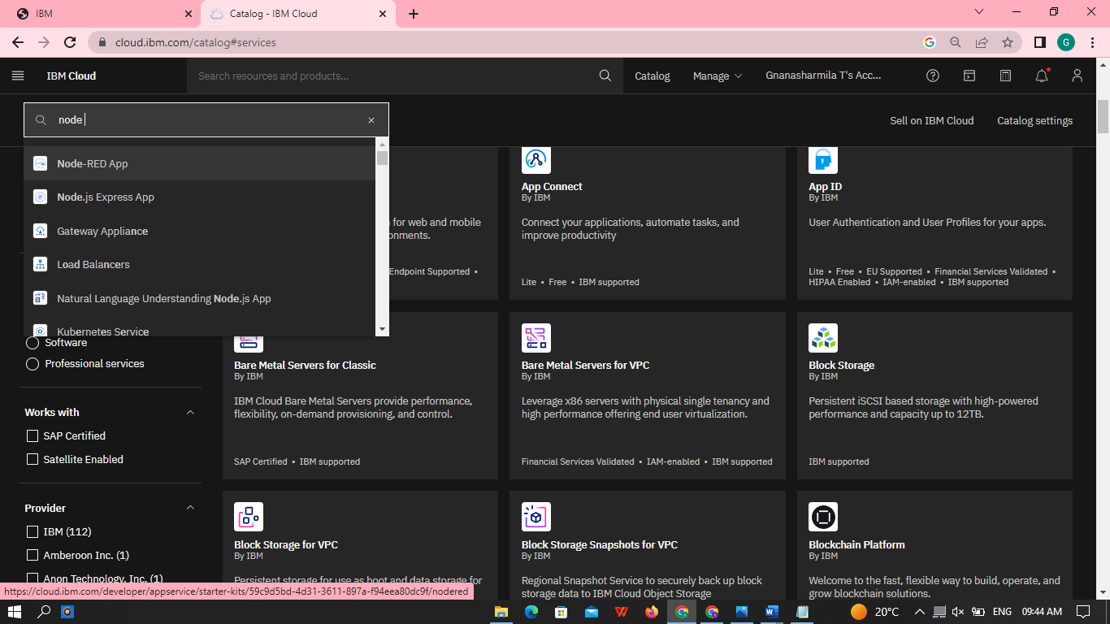

STEP 3:

Click to get started button.

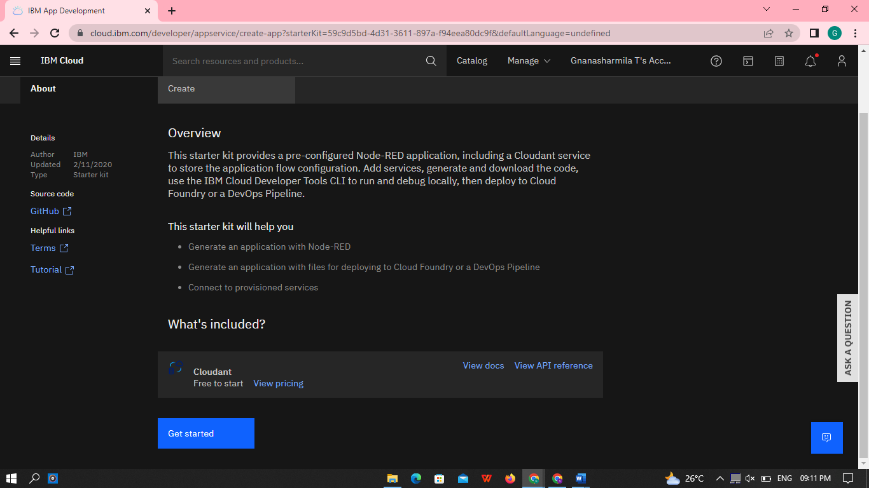

STEP 4:

You need to fill the app details then create. Setting up the environment and deploying the app.

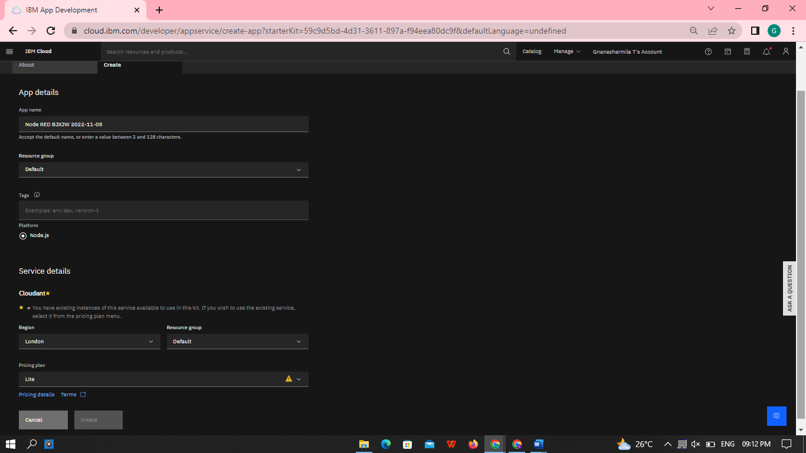

STEP 5:

You need to click the Deploy your app button.

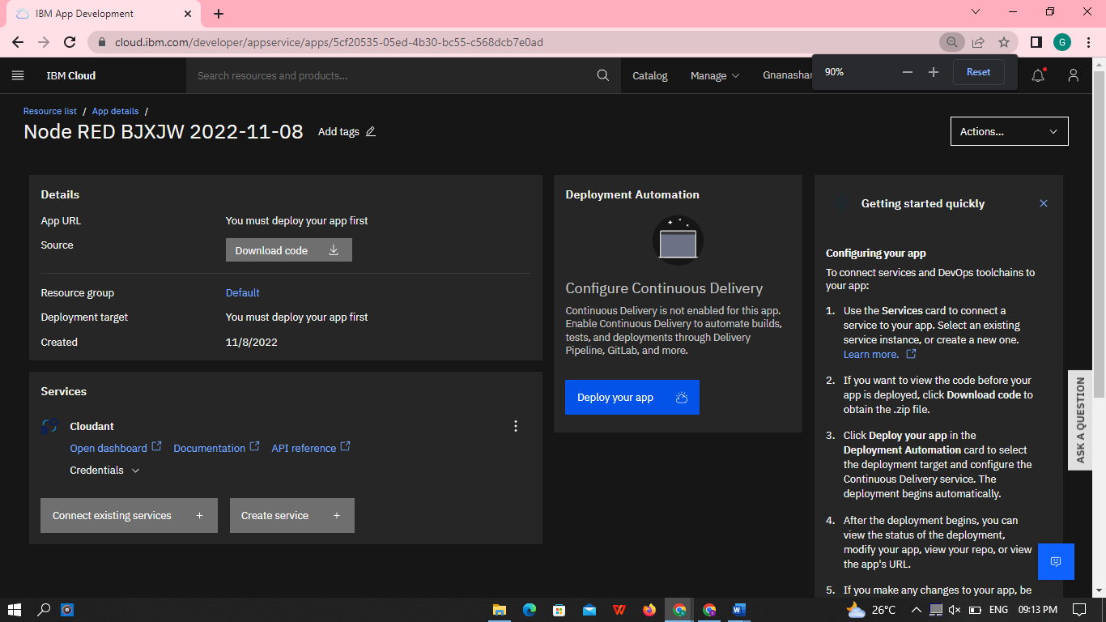

STEP 6:

After you need to select the region as London, then click create button.

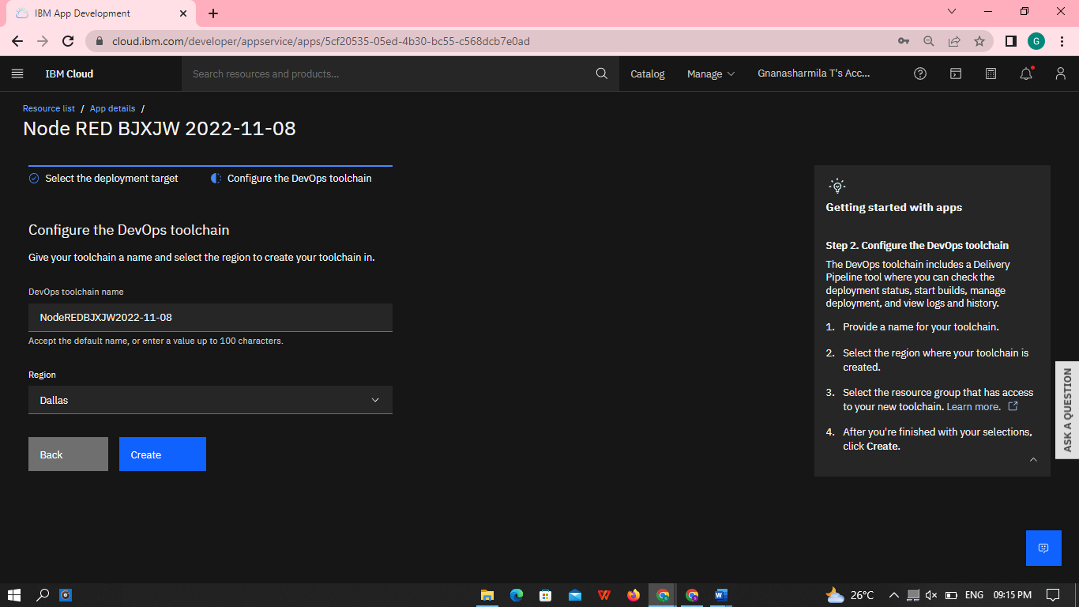

STEP 7:

After you shown this page, then you need to click In-progres.

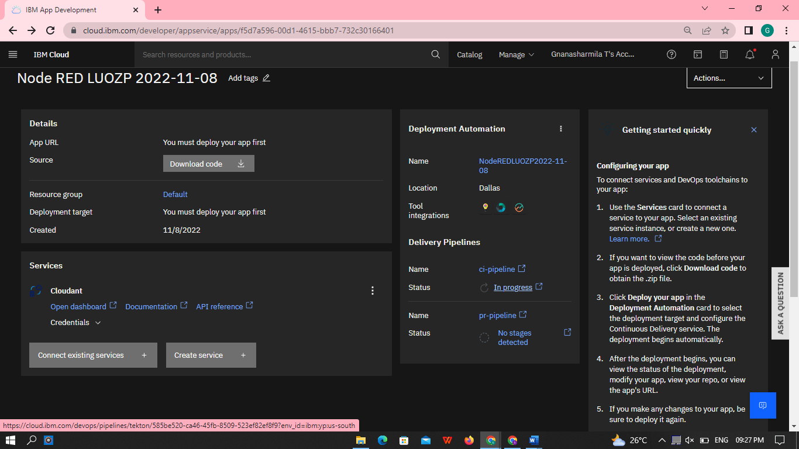

STEP 8:

Successfully deployed the app.

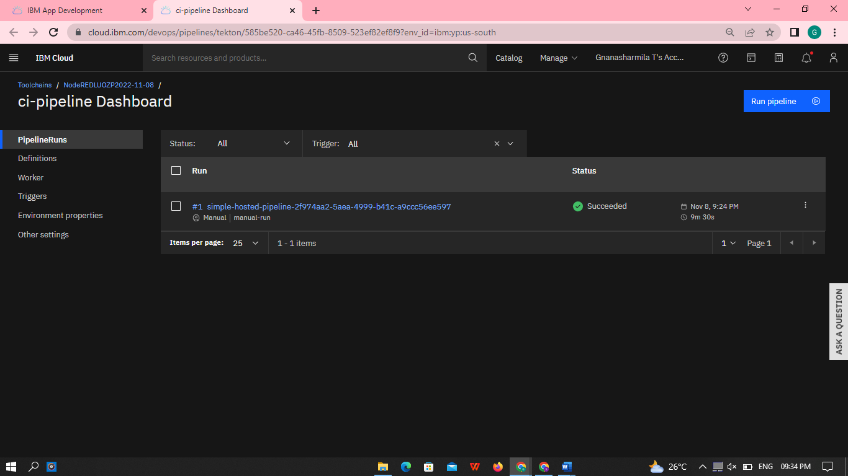

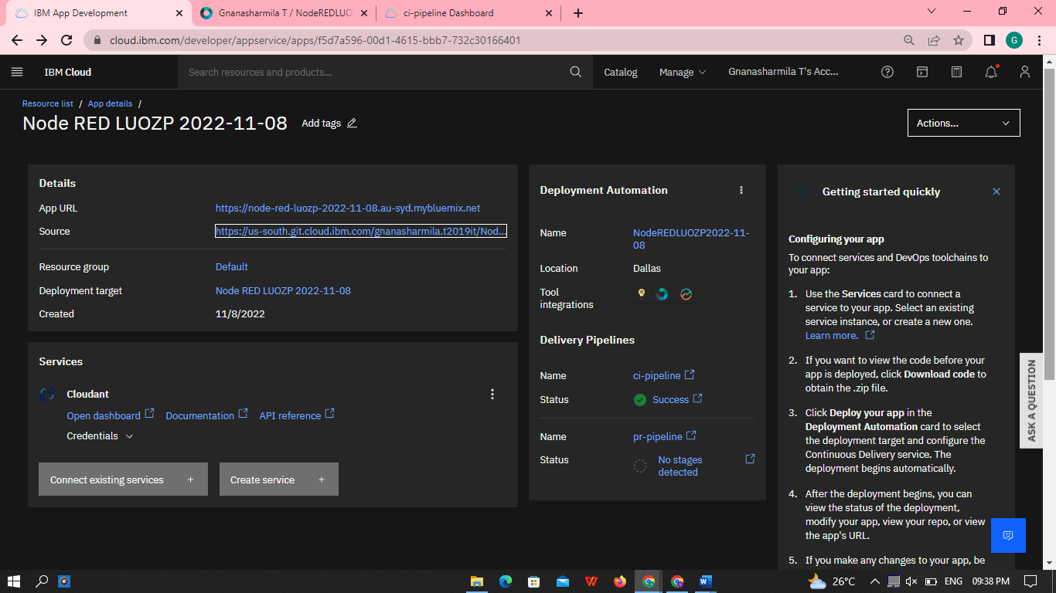

* Welcome by instance editor

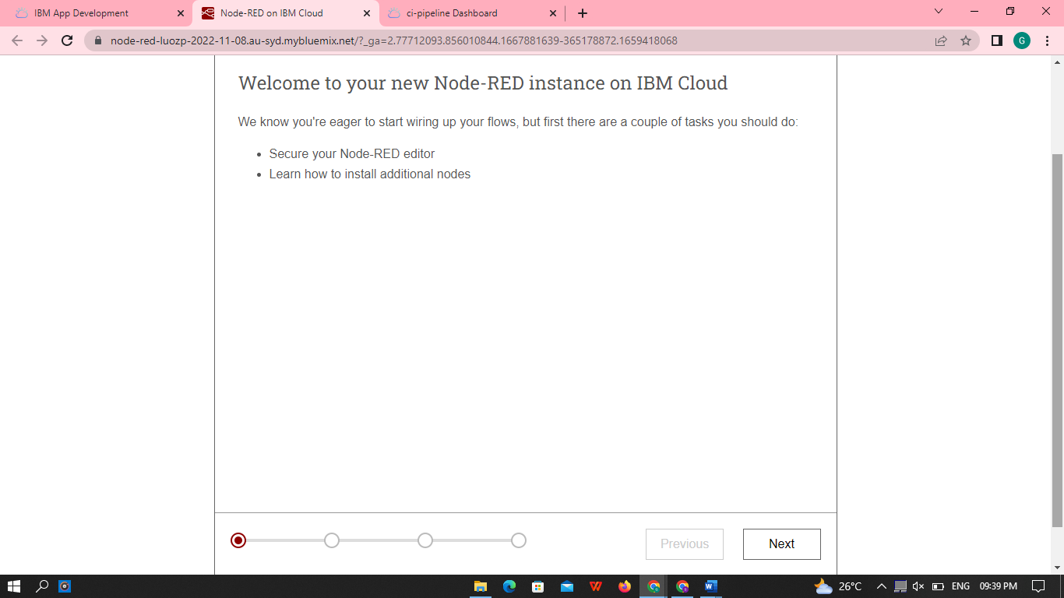

* . Setting up creational ,You need to click Not recommended

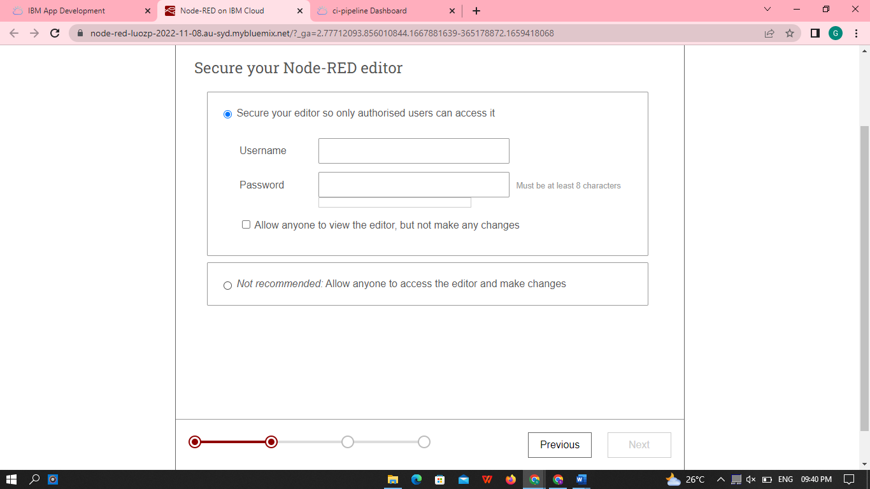

* You learn to how to install the app, after click next button.

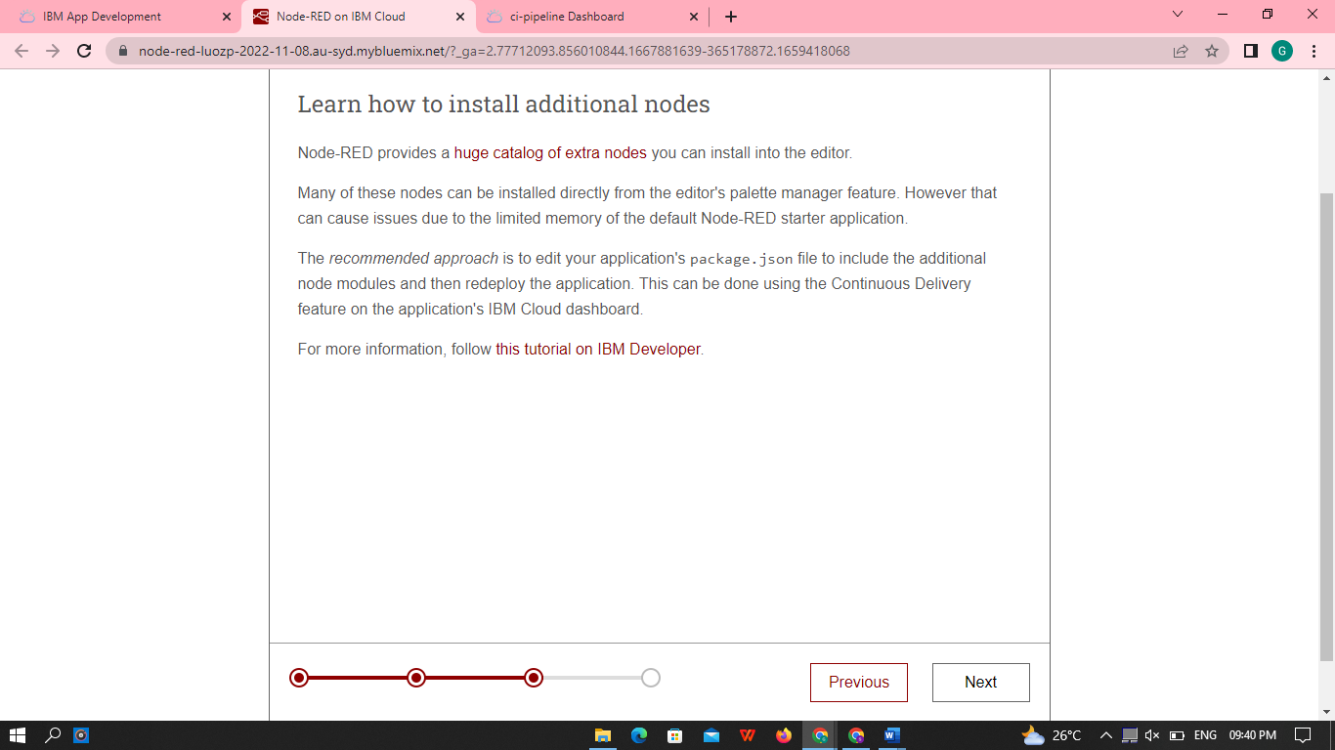

* Finish the install

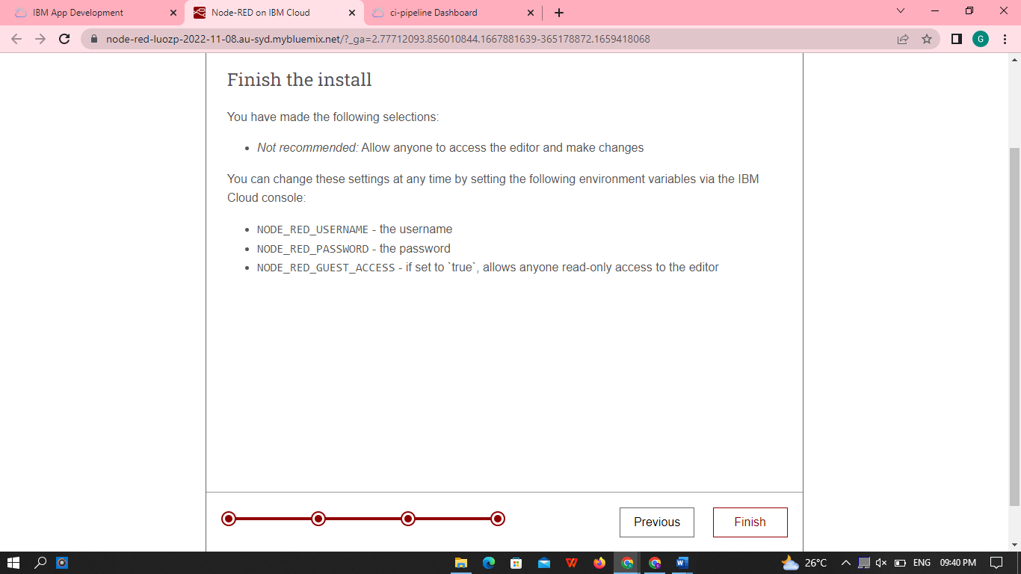

STEP 9:

Node-Red on IBM cloud , click the go to your NODE-RED flow editor.

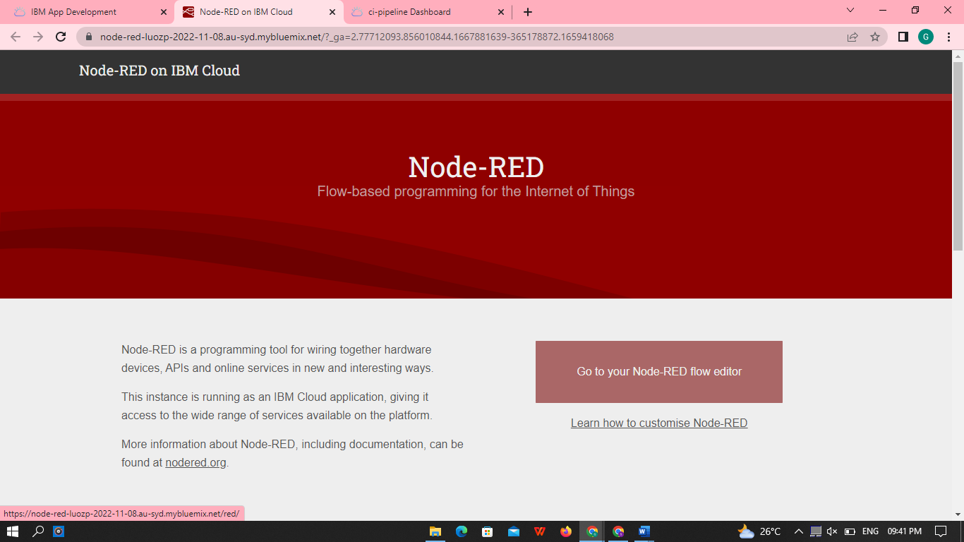

STEP 10:

This is your NODE-RED app, editing to some values.

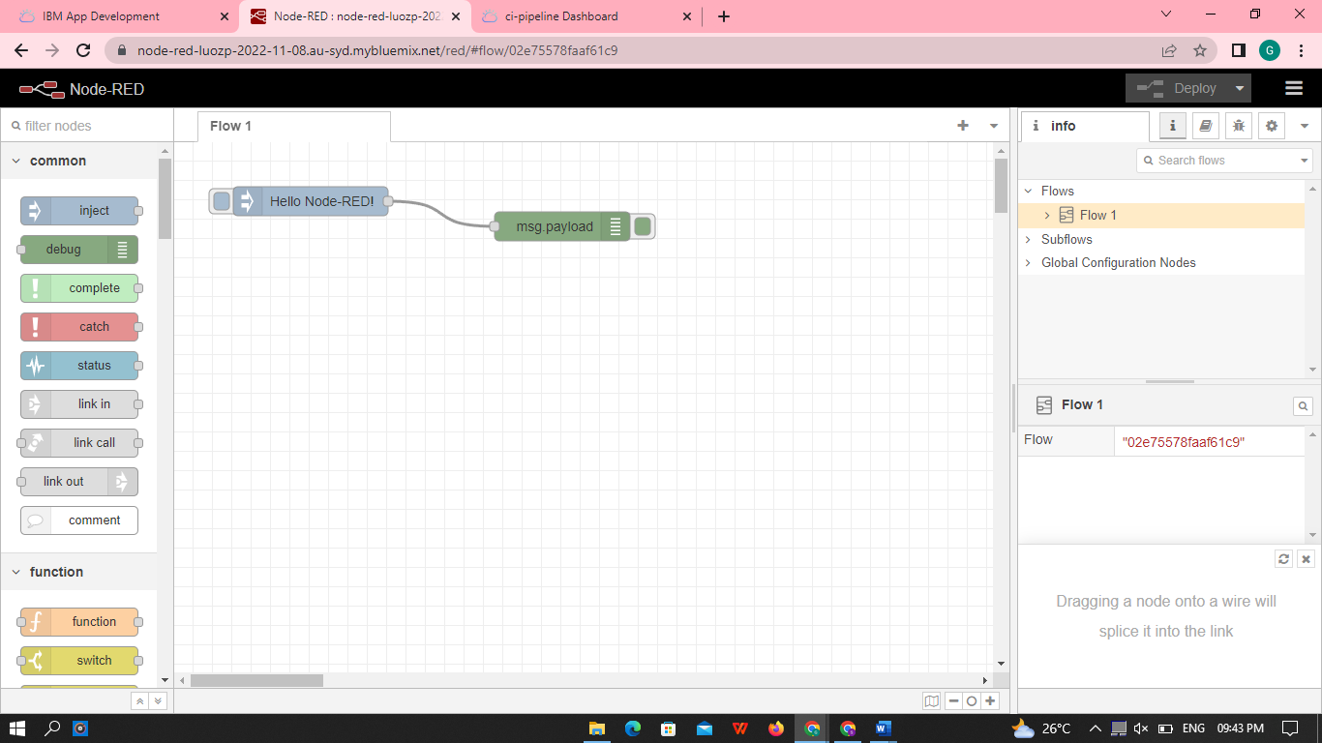

RESULT:

Successfully deployed the app.